Puppy Socialisation
Socialisation is creating a positive experience for your puppy whilst preparing it for life in the outside world. Between 0-16 weeks is the key time to socialise a puppy to new environments and experiences. Puppy have a critical Socialisation window which closes around 16 weeks. This is not to say that after 16 weeks you can’t socialise a puppy – you can but the earlier the better in most cases.

Socialisation should be a positive experience for a puppy. This is not the same as exposing your puppy to an environment – the puppy needs to enjoy the experience. If you take the puppy to a ‘puppy party’ for example and the puppy is chased by other puppies this isn’t the same positive experience to meeting another dog as a controlled 1 on 1 sniff. There is a huge difference and it can make a huge impact on your puppy’s temperament and development.

It is important to let your puppy explore the world at its own pace. Don’t try to rush them or force them. It is much better for your puppy to observe something from afar than it is to force them into a situation and make them uncomfortable. You should never drag a puppy up to something on its lead to make them experience it. Once they are confident to move forward on their own, praise and reward the puppy.

How much should we socialise?

A Puppy need lots of positive experiences to new situations so as much as you can give them before the Socialisation window ends is the key. However, I you can only expose the puppy to something twice in that window – as long as it was a positive experience on both occasions it shouldn’t be a problem. Better to have 2 positive experiences than 50 where some are bad.
What to socialise?
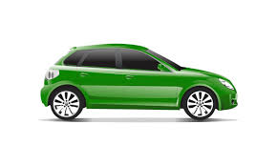
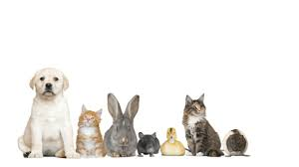
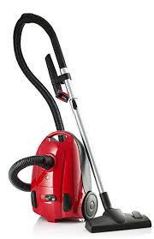

Other Animals: Cats, Dogs, Horses, Rabbits, Ducks, Sheep, Cows – Anything you feel your puppy may encounter in life. The pet shop can be a good place to see other animals as they are often behind a glass barrier to it is safe for both them and your puppy. Meeting other dogs is important – not just so your puppy can learn to play with other dogs – ignoring other dogs and paying attention to you is far more important. YOU should be the main source of your puppy’s fun – not other dogs in the park.

People: Men, Women, Children, People with hats, glasses, sunglasses, coats, umbrellas, pushchairs, wheelchairs – As much as you can think of!

Noises: Hoover, washing machine, lawnmower, sirens, traffic. A puppies hearing is much more sensitive than ours so pair high noise experiences with something fun like a treat or a game

Handling: Your puppy will need to be handled throughout its life by you, your vet and a trainer if you are going to classes. It’s important to ensure your puppy is happy with being handled for inspection. Ears, eyes, nose, teeth, inside the mouth, feet (front and back), testicles (male), penis, vulva, tail, coat all over are things to regularly check. With a puppy pair handling with giving treats so your puppy doesn’t learn the only time you want to look in its mouth is to take something out it shouldn’t have! Sometimes you’ll look and give a treat – making it a positive experience.

Surfaces: Grass, wet grass, concrete, gravel, sand, water, bubble wrap, carpet, Lino, tiles. Also balancing on surfaces that may wobble or move (a rope bridge)

Locations and experiences: The Vets, Beach, Woods, other people’s houses, car travel, train & other vehicle travel (if likely to be needed)
What about unvaccinated puppies?

Once your puppy has had its first vaccine it is vitally important to let it start to experience the world otherwise buy the time it has had its second vaccine and waited the recommended 2 weeks the socialisation window is almost closed. This isn’t to say put your puppy down and let them get on with it – you need to be careful. Avoid unvaccinated dogs, dog parks and pet shops (putting your dog down) as there are many unknown dogs here but a small puppy class, carrying your puppy so it can see the world or taking them out in a dog pushchair or backpack can be a great way for them to experience the world in this crucial time.

You might think that socialising your puppy whilst practicing social distancing is impossible but it’s actually not a bad thing. It means your puppy can experience everything at a safe distance without being overwhelmed. You can still introduce vehicle training by regularly putting your puppy in the car and starting the engine and then rewarding it for being quiet and calm – you don’t have to actually drive anywhere to have a positive experience. Use your imagination and above all – have fun!

